Registered Charity No: 1059310
A Company Limited by Guarantee Registration No 32655669

Director: Alison Mather
PO Box 3344
Bristol BS6 9NT
0117 924 6981
E- mail: alison@qaad.org
Website: www.qaad.org
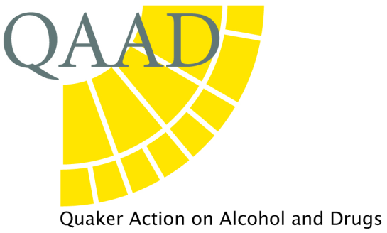

QAAD DONATION: GIFT AID

I am a UK Taxpayer and want QAAD to treat all donations I have made for the past four years, and all future donations I make from the date of this declaration as Gift Aid Donations until I notify you otherwise.

I understand that I must pay an amount of Income Tax and/or Capital Gains Tax for each tax year that is at least equal to the amount of tax reclaimed on my donations in the appropriate tax year.

I understand that if I pay less Income and/or Capital Gains Tax to cover the amount of Gift Aid claimed on all my donations in that tax year, it is my responsibility to pay back any difference.

Full Name …………………………………………………………………….......................................................................

Address………………………………………………………………………………………………………………………………………………

………………………………………………………………………… Post Code………………………......................................

Signed…………………………………………………………………… Date……………………..........................................

The amount of a collection of cash and cheques taken in aid of QAAD can be enhanced under GASD (Gift Aided Small Donations of £30 or less). Please let us know when and where the collection was taken. It is not necessary to list individual donors.

